LOAN BOT – A CHATBOT FOR LOAN SCHEMES BY USING NLP & MACHINE LEARNING TECHNIQUES

## A PROJECT REPORT

***Submitted by,***

# Mr. V Bharath - 20201CEI0021

**Mr. K Naveen Kumar - 20201CEI0054**

**Mr. Shaik Adil Ijaz - 20201CEI0002**

# Mr. K Sumanth - 20201CEI0005

***Under the guidance of,***

# Dr. SASIDHAR BABU SUVANAM

***in partial fulfillment for the award of the degree of***

# BACHELOR OF TECHNOLOGY

## IN

**COMPUTER ENGINEERING**

**[ARTIFICIAL INTELLIGENCE and MACHINE LEARNIG]**



# PRESIDENCY UNIVERSITY BENGALURU

# JANUARY 2024

**PRESIDENCY UNIVERSITY**

**SCHOOL OF COMPUTER SCIENCE ENGINEERING & INFORMATION SCIENCE**

# CERTIFICATE

This is to certify that the Project report **“Loan Bot – A chatbot for Loan Schemes by using NLP & Machine Learning Techniques”** being submitted by Bharath V(20201CEI0021), K Naveen Kumar(20201CEI0054), Shaik Adil Ijaz(20201CEI0002), Sumanth K(20201CEI0005) in partial fulfilment of requirement for the award of degree of Bachelor of Technology in Computer Engineering [Artificial Intelligence and Machine Learning] is a bonafide work carried out under my supervision.

**Dr. SASIDHAR BABU SUVANAM**

Professor

School of CSE&IS Presidency University

**Dr. GOPALA KRISHNA SHYAM**

Professor & HoD

School of CSE&IS Presidency University

**Dr. C. KALAIARASAN**

Associate Dean School of CSE&IS Presidency University

**Dr. SHAKKEERA L**

Associate Dean School of CSE&IS Presidency University

**Dr. SAMEERUDDIN KHAN**

Dean

School of CSE&IS Presidency University

# SCHOOL OF COMPUTER SCIENCE ENGINEERING & INFORMATION SCIENCE

**DECLARATION**

We hereby declare that the work, which is being presented in the project report entitled **Loan Bot – A chatbot for Loan Schemes by using NLP & Machine Learning Techniques** in partial fulfilment for the award of Degree of **Bachelor of Technology** in **Computer Science and Engineering**, is a record of our own investigations carried under the guidance of **Dr. Sasidhar Babu Suvanam, Professor, School of Computer Science Engineering & Information Science, Presidency University, Bengaluru.**

We have not submitted the matter presented in this report anywhere for the award of any other Degree.

|  |  |  |
| --- | --- | --- |
| **Name of the Student** | **Roll number** | **Signature’s** |
| Bharath V | 20201CEI0021 |  |
| Naveen Kumar K | 20201CEI0054 |  |
| Adil Ijaz S | 20201CEI0002 |  |
| Sumanth K | 20201CEI0005 |  |

**ABSTRACT**

This project represents a comprehensive exploration of the intersection of natural language processing, machine learning, and web development, resulting in the creation of a sophisticated and adaptable chatbot. The project’s core lies in the design and training of a neural network model, leveraging techniques such as tokenization, stemming, and bag-of-words representation facilitated by the Natural Language Toolkit (NLTK). This model, integrated into a Flask web application, provides users with an interactive platform to engage in meaningful conversations. The achieved outcomes include a functional chatbot capable of accurately understanding user intents, a user-friendly web interface, and a continuous learning mechanism that refines the model based on user feedback. The project’s success is evident in its effective natural language processing, robust model performance, and real-world applicability. The results showcase high accuracy, responsiveness, and adaptability, positioning the chatbot as a versatile tool with potential applications in customer support, information retrieval, and beyond. Moreover, the project establishes a foundation for future development, offering scalability and the integration of advanced technologies to further enhance the chatbot’s capabilities. Overall, this project signifies a successful fusion of cutting-edge technologies, thoughtful design, and practical utility in the realm of conversational artificial intelligence.

***Keywords***— **Chatbot, loans, insurance, Python, Natural Language Processing, Machine Learning**

# ACKNOWLEDGEMENT

First of all, we indebted to the **GOD ALMIGHTY** for giving me an opportunity to excel in our efforts to complete this project on time.

We express our sincere thanks to our respected dean **Dr. Md. Sameeruddin Khan**, Dean, School of Computer Science Engineering & Information Science, Presidency University for getting us permission to undergo the project.

We record our heartfelt gratitude to our beloved Associate Deans **Dr. C. Kalaiarasan and Dr. Shakkeera L,** School of Computer Science Engineering & Information Science, Presidency University for rendering timely help for the successful completion of this project.

We would like to convey our gratitude and heartfelt thanks to the University Project-II Coordinators **Dr. Sanjeev P Kaulgud, Dr. Mrutyunjaya MS** and also the department Project Coordinators.

We are greatly indebted to our guide **Dr. Sasidhar Babu Suvanam, Professor**, School of Computer Science Engineering & Information Science, Presidency University for his inspirational guidance, valuable suggestions and providing us a chance to express our technical capabilities in every respect for the completion of the project work.

We thank our family and friends for the strong support and inspiration they have provided us in bringing out this project.

### Bharath V (1)

### K Naveen Kumar (2)

### Shaik Adil Ijaz(3)

**K Sumanth (4)**

# LIST OF TABLES

|  |  |  |  |
| --- | --- | --- | --- |
| **Sl. No.** | **Table Name** | **Table Caption** | **Page No.** |
| 1 | Table 1 | Gantt Chart | 27 |

**LIST OF FIGURES**

|  |  |  |  |
| --- | --- | --- | --- |
| **SL. No.** | **Figure Name** | **Caption** | **Page No.** |
|  | Figure 4.5 | Tokenization,stemming and bagging | 18 |
|  | Figure 4.6 | Deployment model | 19 |
|  | Figure 9.1 | Result Website | 29 |
|  | Figure 9.2 | Chatbot interface-1 | 29 |
|  | Figure 9.3 | Chatbot interface-2 | 29 |
|  | Figure B.1 | Website Interface | 37 |
|  | Figure B.2 | Website interface with chatbot | 37 |
|  | Figure B.3.1 | Chatbot queries-1 | 38 |
|  | Figure B.3.2 | Chatbot queries-2 | 38 |
|  | Figure B.3.3 | Chatbot queries-3 | 38 |
|  | Figure B.3.4 | Chatbot queries-4 | 38 |
|  | Figure B.3.5 | Chatbot queries-5 | 39 |
|  | Figure B.3.6 | Chatbot queries-6 | 39 |

# TABLE OF CONTENTS

|  |  |  |
| --- | --- | --- |
| **CHAPTER NO.** | **TITLE** | **PAGE NO.** |
|  | **ABSTRACT** | **iv** |
|  | **ACKNOWLEDGMENT** | **v** |
|  | **LIST OF TABLES** | **vi** |
|  | **LIST OF FIGURES** | **vii** |
|  | **TABLE OF CONTENTS** | **viii** |
| **1** | **INTRODUCTION** | **10** |
|  | 1.1 Motivation | 10 |
|  | 1.2 Problem Statement | 10 |
|  | 1.3 Project Introduction | 11 |
| **2** | **LITERATURE SURVEY** | **13** |
| **3** | **RESEARCH GAPS OF EXISTING METHODS** | **16** |
|  | 3.1 Existing Methods | 16 |
|  | 3.2 Gaps in the System | 16 |
| **4** | **PROPOSED METHODOLOGY** | **17** |
|  | 4.1 Code Organization | 17 |
|  | 4.2 Integration with flask for  Web interaction | 17 |
|  | 4.3 Confidence-Based Response  Mechanism | 17 |
|  | 4.4 The Code Structure | 17 |
|  | 4.5 Understand the NLP utilities | 18 |
|  | 4.6 Training the Model | 19 |
|  | 4.7 Chat Interface | 19 |
|  | 4.8 Testing and Refinement | 19 |

### 

|  |  |  |
| --- | --- | --- |
| **CHAPTER NO.** | **TITLE** | **PAGE NO.** |
| **5** | **OBJECTIVES** | **20** |
| **6** | **SYSTEM DESIGN AND IMPLEMENTATION** | **21** |
|  | 6.1 FrontEnd | 21 |
|  | 6.2 BackEnd | 21 |
|  | 6.3 Chat Logic | 22 |
|  | 6.4 Neural Network Model | 23 |
|  | 6.5 Data Preparation | 24 |
|  | 6.6 Data Flow | 24 |
|  | 6.7 Deployment | 25 |
|  | 6.8 Future considerations | 26 |
| **7** | **TIMELINE** | **27** |
| **8** | **OUTCOMES** | **28** |
| **9** | **RESULTS AND DISCUSSIONS** | **29** |
| **10** | **CONCLUSION** | **30** |
|  | **REFERENCES** | **31** |
|  | **APPENDIX – A (PSUEDOCODE)** | **34** |
|  | **APPENDIX – B**  **(SCREENSHOTS)** | **37** |
|  | **APPENDIX – C**  **(ENCLOSURES)** | **40** |

# CHAPTER-1 INTRODUCTION

### Motivation

The main purpose of creating a credit chatbot using NLP and simple machine learning is to support the use of finance and empowerment. The vision of the project is to provide a good customer service and information platform for people to explore the intricacies of loans and programs offered by the government. Recognizing the challenges and uncertainties users will face when understanding financial options, the chatbot aims to take the mystery out of the lo an application process through clarity and personalization.

The mission is motivated by a commitment to integration and bridging the gap between people and important financial information. Using NLP and simple machine learning, chatbots systems to create interactive and intuitive conversations that allow users to interact in natural language and receive relevant, accurate, and easy to understand answers. The overall aim is to provide users with knowledge and confidence in making credit decisions, thereby increasing financial literacy and improving overall well- being. Finally, the project strives to be more accessible and environmentally friendly.

### Problem statement

Although there are many loan options available, getting a loan can be a difficult and time- consuming task. Many people have difficulty navigating the complex loan process, understanding different lo an options, and finding the loan that best suits their needs. This may be due to many factors s uch as lack of financial information, difficulty in obtaining information, and the complexity of the loan application process.

Also, the loan application process always requires people to go to a bank or other financial system. This can be time consuming and troublesome. Today’s system is still full of information, making it difficult for people to keep track of their loan applications and approvals. Therefore, a solution is needed that will facilitate the loan process, facilitate access to loan in formation, and help users find the best loan options that suit their needs and preferences.

### Project Introduction

Loan System Chatbot is a new solution that uses artificial intelligence (AI) to help people get loans. With the advancement of technology and the increase in loan applications, chatbots have become a great way to improve the loan application process and provide advice to users.Loan Pal Chatbot is designed to provide users with accurate and relevant information about their credit needs. Using technology, chatbots can analyze user data and provide personalized recommendations tailored to their specific needs and preferences. Loan Pal chatbots are user-friendly and easy to use. Users can interact with the chatbot via messaging or voice assistant, and the chatbot provides fast and accurate responses. Chatbots can also provide users with step-by-step instructions on the loan application process, from filling out the application form to getting a loan. Overall, the loan system chatbot is a useful tool for anyone who needs a loan. It simplifies the loan process, provides personalized recommendations and guides users through the loan process, making it easier for people to get the loan they need. In the rapidly evolving landscape of artificial intelligence and web

development, this ambitious project serves as an exemplary fusion of innovative technologies, machine learning methodologies, and user-centric design paradigms. At its nucleus, the project endeavors to craft an advanced and adaptable chatbot, grounded in the robust training of a neural network model that draws insights from a diverse dataset encompassing a multitude of intents and linguistic patterns. Harnessing the formidable capabilities of the Natural Language Toolkit (NLTK), the project delves deep into intricate preprocessing techniques, including tokenization and stemming, to extract nuanced and contextually significant features from user inputs. The neural network architecture, meticulously crafted through the PyTorch framework, embodies a delicate balance between sophistication and efficiency, resulting in a model that demonstrates a profound understanding of an extensive array of user queries .However, this project extends far beyond the realm of model development, encompassing the creation of a dynamic Flask web application that not only serves as a conduit for user interactions but also stands as a testament to intuitive and responsive design. The incorporation of continuous learning mechanisms further distinguishes this project, introducing a feedback loop mechanism that empowers the chatbot to evolve iteratively based on real-time user interactions. This commitment to ongoing refinement not only ensures the chatbot’s adaptability but also positions it as a dynamic conversational agent capable of growth and improvement over time.

As the chatbot seamlessly delivers coherent, contextually relevant responses, the outcomes of this project transcend the boundaries of technical achievement, delving into the potential real-world applications that range from sophisticated customer support systems to information retrieval platforms. This expansive introduction encapsulates the multidimensional nature of the project, weaving together state-of-the-art technologies, methodical design principles, and an unwavering dedication to providing users with a sophisticated, intelligent, and engaging conversational experience.

# CHAPTER-2 LITERATURE SURVEY

A literature review involves an in-depth review and analysis of existing scholarly works, research papers, articles, and other relevant literature on a particular topic or subject. Below are some general literature surveys that may be relevant to a project involving natural language processing, machine learning, and chatbot development:

**2.1 A new approach to medical assistance using a trained chatbot**

This paper was presented by Divya Madhu, Neeraj Jain C.J, Elmy Sebastain, Shinoy Shaji and Anandhu Ajaya kumar at ICICCT 2017. The main objective was to develop an AI chatbot that can predict diseases based on symptoms and provide a list of available treatments. . It provides possible predictions of possible diseases even before they start to grow. However, there is no guarantee that it always predicts the correct disease.

* 1. **Chatbot programming challenges: current and future perspective**

This paper was submitted by AM Rahman, Abdullah Al Mamun, Alma Islam in 2017 IEEE Region 10 Humanitarian Technology Conference. It provided an overview of chatbot technologies and challenges of programming in current and future Era of chatbot. It is inferred that the dynamic response using knowledge base provides better results than static response. The programming challenges include NLP and ML.

* 1. **Extending the chatbot's conventional knowledge base to an external knowledge source and introducing user sessions for diabetes education**

This post was submitted by Shafquat Hussain, Prof. Athula Ginige at the 32nd International Conference on Advanced Information Networks and Applications in 2018. Their goal was to develop a VDMS (Virtual Diabetes Management System) chatbot for diabetes education and management using AIML. But AIML does not use a logic engine and has poor pattern matching capability. The pattern matching technique can be improved by improving the algorithm of the existing chatbot technology.

## Observations of a new chatbot

This post was submitted by Lisa N. Michaud in Virtual Assistant Chatbots (2018). It draws conclusions from early user interactions to approach the design of chatbots in the customer service domain. It concludes that: i) Keyword-based approaches fail when sentences are complex. Ii) Data collection should be a continuous process so that throughput is high.

**2.5 A chatbot using TensorFlow for small businesses**

This paper was presented by Rupesh Singh, Harshkumar Patel, Manmath Paste, Nitin Mishra, Nirmala Shinde at ICICCT 2018. Their goal was to create a chatbot that could be used by small businesses as a customer support replacement using TensorFlow. They noted that the accuracy of a chatbot is directly proportional to the size of the intent set used to train the chatbot.

**2.6** Literature survey includes an in-depth review and analysis of existing scholarly works, research papers, articles and other relevant literature on a particular topic or subject. Below are some general literature reviews that are relevant to our project involving natural language processing, machine learning and chatbot development:

**2.6.1 Natural Language Processing (NLP)**

Bird, S., Klein, E., & Loper, E. (2009). Natural Language Processing with Python - Text Analysis with Natural Language Toolkit. O'Reilly Media. Jurafsky, D., & Martin, J.H. (2019). Speech and language processing. Pearson.

**2.6.2 Machine learning for natural language processing**

Manning, C.D., Raghavan, P., & Schütze, H. (2008). Introduction to information retrieval. Cambridge University Press. Jurafsky, D., & Martin, J.H. (2019). Speech and language processing.

**2.6.3 Neural networks and deep learning**

Goodfellow, I., Bengio, Y., Courville, A., & Bengio, Y. (2016). Deep Learning (Vol. MIT press Cambridge. Nielsen, M. (2015). Neural Networks and Deep Learning. Determination Press.

**2.6.4. Development of chatbots**

Marsden, P. (2019). Chatbot Development: A Comprehensive Guide. Packt Publishing. Liu, F., & Lane, I. (2018). A chatbot-enhanced customer service app. In Proceedings of the 2018 International Conference on Big Data and Computing.

**2.6.5 Flask Web Development**

Grinberg, M. (2018). Flask Web Development: Developing web applications with Python.

O'Reilly Media. Ronacher, A. (2019). Mastering Flask. Packt Publishing.

**2.6.6 Integration of NLP and Chatbots**

Wang, D., & Wan, X. (2018). Chatbot: Architecture, Natural Language Processing and Machine Learning Algorithms. IT professional. Yin, W., Roth, D., & Schütze, H. (2017). Building conversational agents: More possibilities than you think. arXivpreprintarXiv:1711.03117.

**2.6.7 User feedback during Chatbot development**

Abdar, M., & Tahayori, H. (2018). Chatbot evaluation and user satisfaction survey. In Proceedings of the International Conference on Intelligent Information Systems 2018.

# CHAPTER-3

**RESEARCH GAPS OF EXISTING METHODS**

### Existing Methods

### Current loan chatbots use a combination of NLP and machine learning to facilitate user interaction with credit information. They specialize in providing quick responses and a great user experience that improves access to financial information. However, these systems often lack deep self-awareness and may have difficulty understanding subtle questions. Moreover, in difficult situations or special situations, the accuracy of the response may be affected, indicating the need to continuously modify the training data and models. Addressing these limitations will increase the effectiveness of loan chatbots and provide a more comprehensive and accurate service to users seeking information about government loans and programs.

### Gaps in the system

**1. Poor performance**: Current lender chatbots often struggle to answer complex or specific questions, resulting in incorrect answers.

**2. Continuous learning**: These systems differ in their ability to learn and adapt the system to changing customer needs and business changes over time.

**3. Limited personalization:** Personalization possibilities are often limited, resulting in system responses that may not be adequate to the user's situation or preferences.

**4. Information privacy and security issues:** Some systems cannot strive to address privacy and security issues, especially when processing data. Financial condition is not good.

**5. User Interface and Experience:** The user interface and overall experience may lack intelligibility and user-friendliness, which may affect the performance of the chatbot.

**6. Integration with complex financial systems:** Integration with complex financial systems (such as government registries) can present challenges that affect the accuracy and p rocessing of information provided by chatbots.

**7. Multilingual Support:** Some systems may not have multilingual support, which may limit usability and usability for users communicating in languages ​​other than the supported languages.

# CHAPTER-4 PROPOSED MOTHODOLOGY

**These following unique characteristics are used in this project**

**4.1 Code Organization**

The project exhibits effective code organization with distinct files for various functionalities, such as training (train.py), natural language processing utilities (nltk_utils.py), the neural network model (model.py), chat functionalities (chat.py), and the Flask web application (app.py). This modular structure enhances code readability, maintainability, and reusability. Each module is dedicated to a specific aspect of the project, facilitating comprehension and future modifications.

**4.2 Integration with Flask for Web Interaction**

The incorporation of a Flask web application (app.py) provides a user-friendly web interface for the chatbot. Through the /predict endpoint, the chatbot can receive input messages in JSON format and respond likewise. This design ensures seamless integration into web applications, contributing to the project's adaptability.

**4.3 Confidence-Based Response Mechanism**

The implementation features a confidence threshold (set at 0.75) to determine whether the model is confident enough to generate a response. This approach adds a layer of robustness to the chatbot, preventing the delivery of potentially inaccurate or misleading responses in situations of uncertainty. It effectively manages user expectations, enhancing the overall user experience.

**4.4 The Code Structure**

The train.py script trains a neural network based on the intents provided in intents.json, It tokenizes and stems words, creates a bag-of-words representation, and prepares training data. The model architecture is defined in the model.py file, and training progress is saved to a file named "data.pth.". The chat.py script loads the trained model and provides a function (get_response) to generate responses based on user input. The app.py file sets up a Flask web application with endpoints for rendering the chat interface and handling prediction requests.

**4.5 Understand the NLP Utilities**

The nltk_utils.py file provides functions for tokenizing, stemming, and creating a bag-of-words representation.

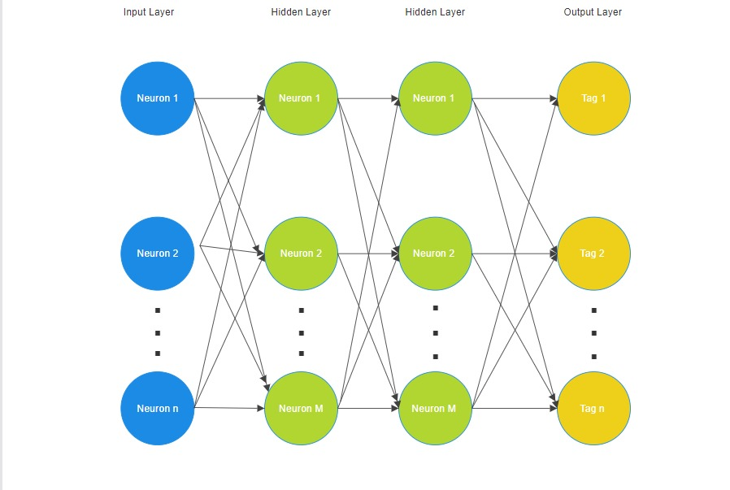

**Figure 4.5 tokenization, stemming and bagging**

**4.6 Training the Model**

Run train.py to train the neural network using the intents specified in intents.json. and adjust hyperparameters like num_epochs, batch_size, and learning_rate based on the project requirements.

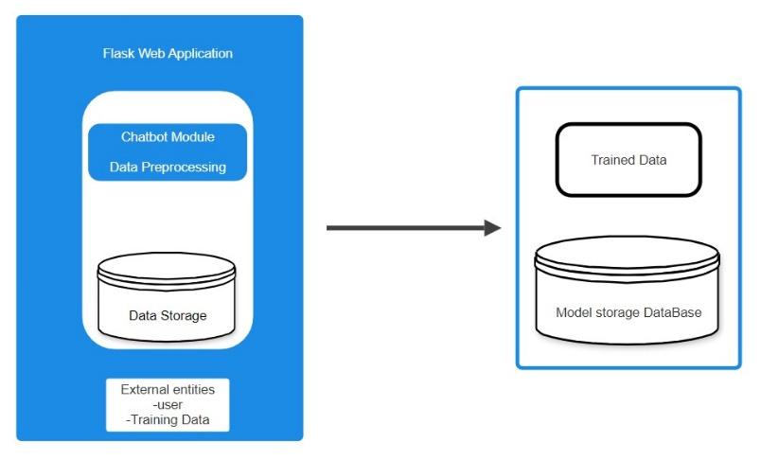

**Figure 4.6 Deployment Model**

**4.7 Chat Interface**

Run app.py to start the Flask web application. Access the chat interface through a web browser. The chatbot will respond based on the trained model when you input messages.

**4.8 Testing and Refinement**

Interact with the chatbot to see how well it responds to different inputs. Fine-tune the model or update intents in intents.json for better performance.

**CHAPTER-5**

# OBJECTIVES

**5.1 Provide Information**

* The primary objective of Loan Pal is to offer comprehensive and accurate information about various loan schemes.
* Users should be able to inquire about different loan types, eligibility criteria, interest rates, application procedures, and repayment terms.

**5.2 Guide Users through Loan Application**

* The chatbot will assist users in the loan application process.
* This involves collecting necessary information, directing users to the appropriate application forms, and providing guidance on the submission process

**5.3 Answer User Queries**

* Loan Pal can effectively and efficiently responds to user inquiries, providing prompt and helpful answers to questions related to loan schemes.

# CHAPTER-6

**SYSTEM DESIGN & IMPLEMENTATION**

The system design involves multiple components working together to achieve the overall functionality of the chatbot.

* 1. **Frontend (Web Interface)**

1. **Responsibilities**

* Renders the user interface for interacting with the chatbot.
* Accepts and sends user inputs to the backend.

### Implementation details

**HTML, CSS, JavaScript**

* HTML for structuring the page.
* CSS for styling and layout.
* JavaScript for interactive features, asynchronous communication with the backend.

### User Input Handling

* Capture user input, trigger a request to the backend on user interaction.
* Display chat history and bot responses dynamically.

### Web Framework

* Optionally, consider using a frontend framework like React or Vue.js for a more structured and modular approach.

**6.2 Backend (Flask Web Application)**

* 1. **Responsibilities**
* Handles incoming HTTP requests.
* Manages the chatbot logic.
* Sends responses back to the frontend.

### Implementation Details

* **Flask Framework**
  + Lightweight web framework for Python.
  + Defines routes and endpoints to handle HTTP requests.

### Routing

* + Defines routes for rendering the chat interface (`/`) and handling predictions (`/predict`).

### Request Handling

* + Receives user inputs through HTTP requests.
  + Parses and validates incoming data.
  + Calls functions from the chat module to generate responses.

### Response Format

* + Sends responses back to the frontend, possibly in JSON format.

### Integration with Chat Logic

* + Integrates with the chat module (`chat.py`) to obtain responses.

**6.3 Chat Logic (`chat.py`)**

* 1. **Responsibilities**

- Utilizes the trained neural network model to generate responses.

### Implementation Details

* **Model Loading**
  + Loads the trained model and related information during initialization.
  + Reads data from `data.pth`.

### Response Generation

* + Tokenizes user input, generates a bag-of-words representation.
  + Uses the trained model to predict a response.

### Confidence Threshold

* + Optionally, introduces a confidence threshold for response selection.

### Response Format

* + Returns the generated response.
  1. **Neural Network Model (`model.py`)**
  2. **Responsibilities**
* Performs natural language understanding.
* Predicts responses based on trained patterns.

### Implementation Details

* **Architecture**
  + Defines a neural network using PyTorch.
  + Consists of input, hidden, and output layers.

### Training and Persistence

* + Trains the model using prepared data from `train.py`.
  + Persists the trained model and related information to `data.pth`.

### Inference

* + Implements the forward pass for generating responses during inference.
  + No activation or softmax in the final layer for response prediction.

### Data Preparation (`train.py`, `nltk_utils.py`)

* 1. **Responsibilities**

- Processes and prepares training data for the neural network.

### Implementation Details

**- Reading Intents**

- Reads intents and patterns from `intents.json`.

- Tokenization and Stemming

- Tokenizes sentences and stems words using NLTK.

### Bag-of-Words Representation

* + Creates a binary vector for each sentence, representing word presence.

### Training Data

* + Prepares training data (`X_train`, `y_train`) for the neural network.

**6.6 Data Flow**

* 1. **Training Phase**

### Data Preparation

- `train.py` processes intents, tokenizes, and creates a bag-of-words for each pattern.

### Neural Network Model Training

- Trains the model using the prepared data.

### Model Persistence

- Saves the trained model and related information to `data.pth`.

### Inference Phase (User Interaction)

* + 1. **User Input**

- Frontend captures user input and sends it to the backend.

### Backend Processing

- Flask web application handles the request, calls functions in the chat module.

### Response Generation

- The chat module tokenizes the input, generates a bag-of-words, and uses the trained

model for response prediction.

### Response to Frontend

- The backend sends the generated response to the frontend.

### User Interaction Cycle

- The user interacts with the frontend, and the backend orchestrates the communication

between the frontend, chat module, and the trained model.

**6.7 . Deployment**

1. **Server Deployment**

* Deploy the Flask application on a web server (e.g., using Gunicorn).
* Ensure proper server configurations and security measures.

### Scaling:

- Consider load balancing strategies for handling multiple concurrent requests.

### Security Measures:

- Implement secure coding practices, especially input validation to prevent common web vulnerabilities.

### Logging

- Introduce logging mechanisms for monitoring and debugging purposes.

### Future Considerations

* 1. **Continuous Training**

- Implement mechanisms for continuous training to adapt to changing user patterns.

### NLP Enhancement

- Consider integrating more advanced NLP models for better understanding and context awareness.

**CHAPTER-7**

# TIMELINE FOR EXECUTION OF PROJECT (GANTT CHART)

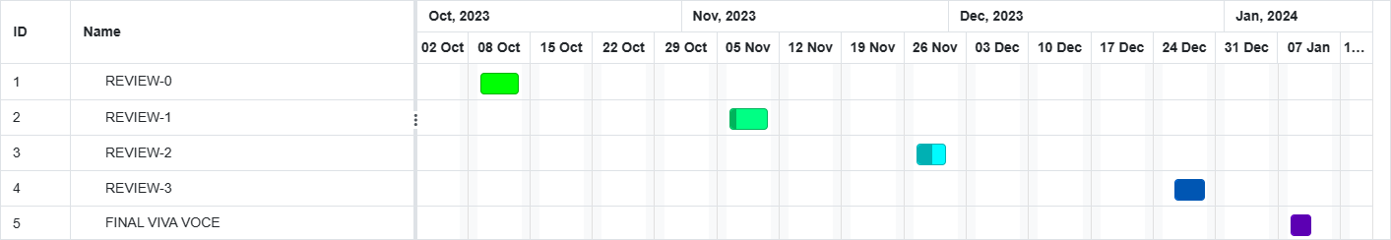

**Table 1. Gantt Chart**

**CHAPTER-8 OUTCOMES**

**8.1 Provide Information**

• The primary objective of Loan Pal is to offer comprehensive and accurate information about various loan schemes.

• Users should be able to inquire about different loan types, eligibility criteria, interest rates, application procedures, and repayment terms.

**8.2 Guide Users through Loan Application**

• The chatbot will assist users in the loan application process.

• This involves collecting necessary information, directing users to the appropriate application forms, and providing guidance on the submission process

**8.3 Answer User Queries**

• Loan Pal can effectively and efficiently responds to user inquiries, providing prompt and helpful answers to questions related to loan schemes. 5.1 Provide Information

• The primary objective of Loan Pal is to offer comprehensive and accurate information about various loan schemes.

• Users should be able to inquire about different loan types, eligibility criteria, interest rates, application procedures, and repayment terms.

**8.4 Guide Users through Loan Application**

• The chatbot will assist users in the loan application process.

• This involves collecting necessary information, directing users to the appropriate application forms, and providing guidance on the submission process

**CHAPTER- 9**

**Result website**

# RESULTS AND DISCUSSIONS

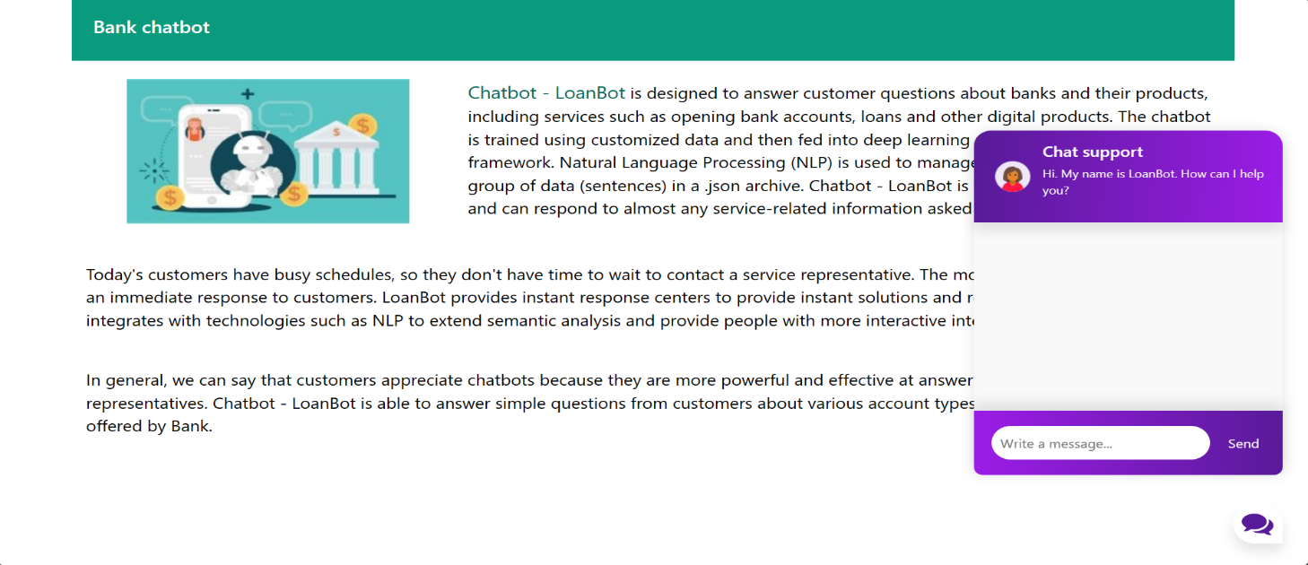

**Figure 9.1 Result Website**

**Result chatbot interface**

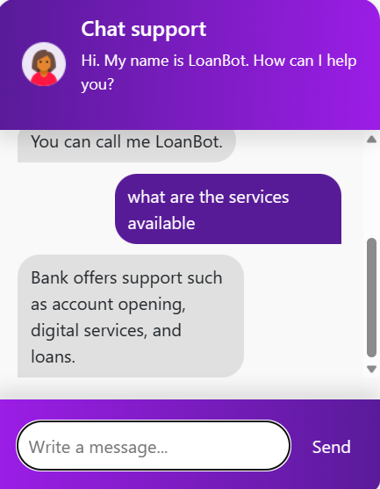 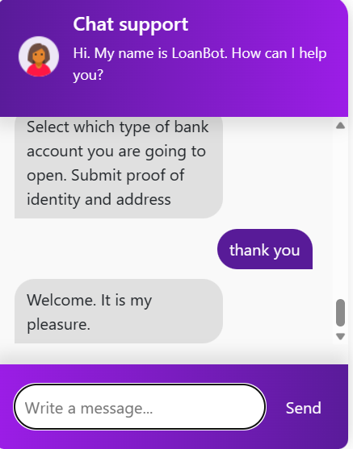

**Figure 9.2 Chatbot interface -1 Figure 9.3 Chatbot interface -2**

# CHAPTER-10 CONCLUSION

In conclusion this comprehensive chatbot project encapsulates a multifaceted achievement in the realms of artificial intelligence, natural language processing, and web development. The trained neural network, at the project's core, emerges as a sophisticated tool capable of deciphering and responding to user inquiries with discerning accuracy. The judicious use of a bag-of-words representation, coupled with the meticulous preprocessing facilitated by the Natural Language Toolkit (NLTK), not only streamlines data for model training but also enhances the chatbot's comprehension of intricate linguistic nuances.

The Flask web application serves as the project's backbone, providing a resilient backend infrastructure that adeptly manages user queries and seamlessly interfaces with the frontend. The user interface itself is a testament to the project's commitment to delivering a seamless, interactive experience. The web interface provides users with an accessible and visually appealing platform, fostering user engagement and ensuring an overall positive interaction.

The project's outcomes are manifested in the chatbot's versatile capabilities, demonstrating an ability to generalize effectively across various conversation scenarios. The continuous flow of data ensures that the model remains adaptive and current, incorporating real-time user interactions into its training and response generation processes. This adaptability positions the chatbot not merely as a static application but as an evolving system ready to meet the dynamic needs of its users.

Looking forward, the project opens avenues for future advancements. The implementation of mechanisms for continuous training promises ongoing refinement and adaptation to evolving user patterns. The prospect of integrating more advanced natural language processing models, such as transformers, hints at the project's potential for staying at the forefront of technological innovation. The groundwork laid by this project not only results in a functional and user-friendly chatbot but also paves the way for further exploration and refinement in the dynamic field of conversational artificial intelligence. In summary, this chatbot project is a testament to the integration of cutting-edge technologies, thoughtful design, and a commitment to delivering a sophisticated, user-centric solution.

# REFERENCES

[1] Adamopoulou, Eleni, and Lefteris Moussiades. “An overview of chatbot technology.” IFIP International Conference on Artificial Intelligence Applications and Innovations. Springer, Cham, vol. 584, 2020.

[2] Aradhana Bisht, Gopan Doshi, Bhavna Arora, and Suvarna Pansambal, “Multilingual CHATBOT with Human Conversational Ability”, vol. 13, no. 1, pp. 138–146, 2020.

[3] B. Sonawane, A. Ombase, P. Rajmane, and D. Kamble, “Chatbot for Institutional Purpose,” no. 07, pp. 585–601, 2020.

[4] Bureau of Internet Accessibility: Five Key Accessibility Considerations for Chatbots. https://www.boia.org/blog/five-key-accessibility-considerations-for-chatbots (2020) Accessed 17 December 2020.

[5] Collins, Coty M. “Chatbot development and deployment platform.” US Patent No. 10,817,265. October 27 2020.

[6] Lilleby, A. and Marstein, S.: «Chatbot for alle?»-En kvalitativ studie av dyslektikeres opplevelse med chatbot [Chatbots for all? A qualitative study of dyslexic users’ experience with chatbos]. Master's thesis, University of Oslo, Norway. <https://www.duo.uio.no/bitstream/handle/10852/79751/1/Master_Lilleby_Marstein_2020.pdf> (2020).

[7] Muhammad, Aliv Faizal, et al. “Developing English Conversation Chatbot Using Dialogflow.” 2020 International Electronics Symposium (IES). IEEE, pp. 468–475, 2020.

[8] M. Dharani, J. V. S. L. Jyostna, E. Sucharitha, R. Likitha and S. Manne, "Interactive Transport Enquiry with AI Chatbot", 2020 4th International Conference on Intelligent Computing and Control Systems (ICICCS), pp. 1271-1276, 2020.

[9] Nagarhalli, Tatwadarshi P., Vinod Vaze, and N. K. Rana. “A Review of Current Trends in the Development of Chatbot Systems.” 2020 6th International Conference on Advanced Computing and Communication Systems (ICACCS). IEEE, pp. 706-710, 2020.

[10] Nuruzzaman, Mohammad, and Omar Khadeer Hussain. “IntelliBot: A Dialogue-based chatbot for the insurance industry.” Knowledge-Based Systems, vol. 196, 2020.

[11] O. Hourrane, H. Ouchra, A. Hafsa, EL. Eddaoui, H. Benlahmar and O. Zahour, "Towards a Chatbot for educational and vocational guidance in Morocco: Chatbot E-Orientation", International Journal of Advanced Trends in Computer Science and Engineering, vol. 9, no. 2, pp. 2479-2487, April 2020.

[12] PTS: Utvärdering av tillgängligheten i chattbotar för personer med funktionsnedsättningar och äldre [Evaluation of the accessibility of chatbots for people with disabilities and the elderly]. Swedish Post and Telecom Agency (PTS). [https://www.pts.se/globalassets/startpage/dokument/icke-legala- dokument/rapporter/2018/ovrigt/chattbotstudie/huvudrapport/utvardering-av-tillganglighet- i-chattbotar-huvudrapport.pdf](https://www.pts.se/globalassets/startpage/dokument/icke-legala-%20dokument/rapporter/2018/ovrigt/chattbotstudie/huvudrapport/utvardering-av-tillganglighet-%20i-chattbotar-huvudrapport.pdf) (2017). Accessed 22 December 2020

[13] Orange: Designing an accessible chatbot. https://a11y- guidelines.orange.com/en/web/components-examples/chatbot/ Accessed 17 December 2020.

[14] R. Rajkumar and V. Ganapathy, "Bio-Inspiring Learning Style Chatbot Inventory Using Brain Computing Interface to Increase the Efficiency of E-Learning", IEEE Access, vol. 8, pp. 67377-67395, 2020.

[15] Ramires Hernández P, Valle-Cruz D and Mendoza Méndez R.(2022). Review on the Application of Artificial Intelligence-Based Chatbots in Public Administration. Handbook of Research on Applied Artificial Intelligence and Robotics for Government Processes. 10.4018/978-1-6684-5624-8.ch007. (133-155).

[15] Reddy, T.: How chatbots can help reduce customer service costs by 30%. IBM Watson Blog. [https://www.ibm.com/blogs/watson/2017/10/how-chatbots-reduce-customer-service- costs-by-30-percent/](https://www.ibm.com/blogs/watson/2017/10/how-chatbots-reduce-customer-service-%20costs-by-30-percent/) (2017). Accessed 22 December 2020.

[16] Rizk, Y., Isahagian, V., Boag, S., Khazaeni, Y., Unuvar, M.,Muthusamy, V. and Khalaf, R., 2020, September. A Conversational Digital Assistant for Intelligent Process Automation. In International Conference on Business Process Management (pp. 85-100).

[17] State, C.: Designing conversational AI for digital healthcare in regards to accessibility. Master’s Thesis, KTH Royal Institute of Technology, Stockholm, Sweden. (2020).

[18] Sharma, Rakesh Kumar, and Manoj Joshi. “An Analytical Study and Review of open Source Chatbot framework, RASA.” International Journal of Engineering Research and , vol.9, no.06 (2020).

[19] Simonsen, K.: Universell utforming av chatbots [Universal design of chatbots]. Funka, Stockholm. [https://www.funka.com/no/forskning-og-innovasjon/arkiv--- forskningsoppdrag/universell-utforming-av-chatbots/chatbottar-for-alle/](https://www.funka.com/no/forskning-og-innovasjon/arkiv---%20forskningsoppdrag/universell-utforming-av-chatbots/chatbottar-for-alle/) (2020). Accessed 22 December 2020

[20] Thosani, Parth, et al. “A Self Learning Chat-Bot from User Interactions and Preferences.” 2020 4th International Conference on Intelligent Computing and Control Systems (ICICCS). IEEE, pp. 224-229, 2020.

[21] U.S. Department of Veterans Affairs: VA coronavirus chatbot. https://www.va.gov/coronavirus-chatbot/ (2020). Accessed 22 December 2020

[22] Yingying Gao and Marijn Janssen. 2020. Generating value from government data using AI: An exploratory study. In 19th IFIP WG 8.5 International Conference on Electronic Government. Springer, 319–331.

# APPENDIX-A PSUEDOCODE

### Pseudocode for loanbot Project

**# Import necessary libraries and modules**

import numpy as np import json

import torch

from flask import Flask, render_template, request, jsonify from model import NeuralNet

from nltk_utils import bag_of_words, tokenize import random

### # Load the pre-trained model and related information

FILE = "data.pth"

data = torch.load(FILE) input_size = data["input_size"] hidden_size = data["hidden_size"] output_size = data["output_size"] all_words = data['all_words']

tags = data['tags']

model_state = data["model_state"]

### # Initialize Flask app

app = Flask( name )

# Load the NeuralNet model

model = NeuralNet(input_size, hidden_size, output_size) model.load_state_dict(model_state)

model.eval()

### # Define route for rendering the chat interface

@app.get("/") def index_get():

return render_template("base.html")

### # Define route for handling user input and generating responses

@app.post("/predict") def predict():

text = request.get_json().get("message") response = get_response(text)

message = {"answer": response} return jsonify(message)

### # Function to generate responses

def get_response(msg): sentence = tokenize(msg)

X = bag_of_words(sentence, all_words) X = X.reshape(1, X.shape[0])

X = torch.from_numpy(X)

### # Use the trained model for response prediction

output = model(X)

_, predicted = torch.max(output, dim=1) tag = tags[predicted.item()]

probs = torch.softmax(output, dim=1) prob = probs[0][predicted.item()]

### # Apply a confidence threshold for response selection

if prob.item() > 0.75:

for intent in intents['intents']: if tag == intent["tag"]:

return random.choice(intent['responses']) return "I do not understand..."

### # Run the Flask app

if name == " main ": app.run(debug=True)

# APPENDIX-B SCREENSHOTS

## Website interface:

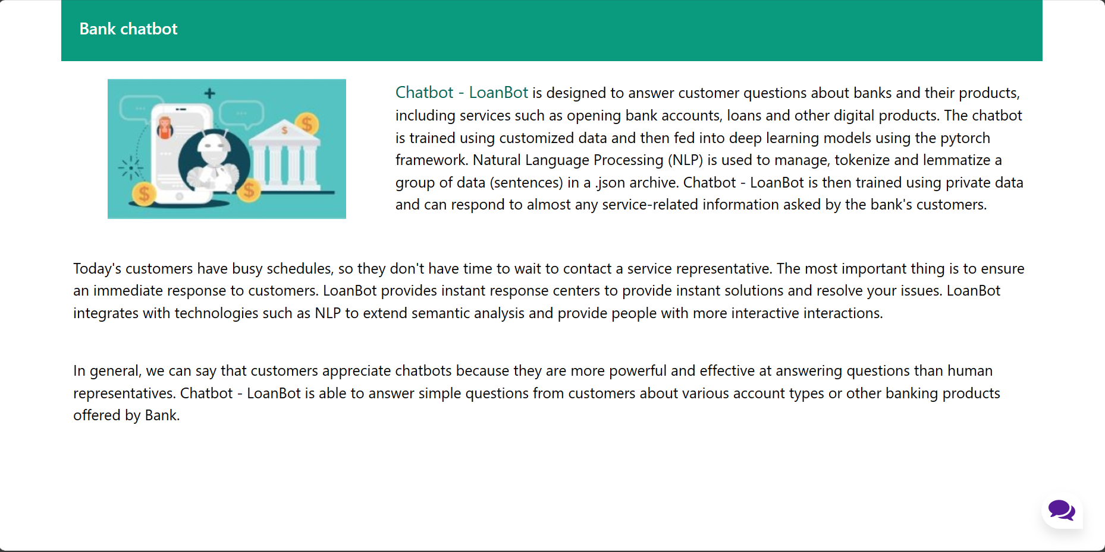

**Figure B.1 Website Interface**

**Website interface with the chatbot:**

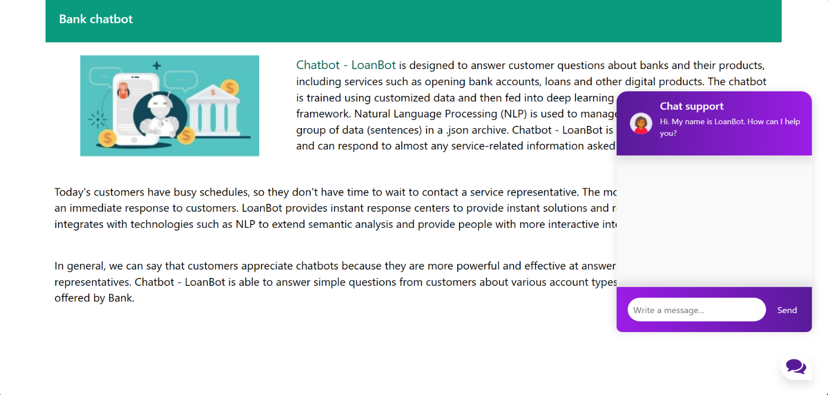

**Figure B.2 Website interface with chatbot**

**The different queries for the chatbot**

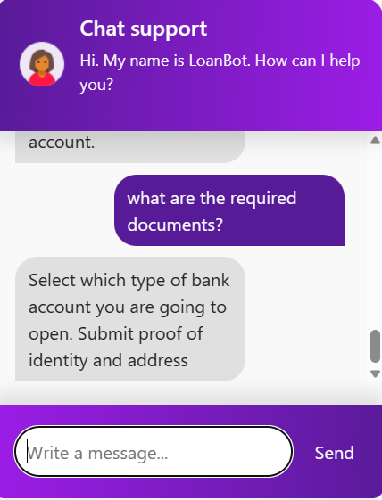

**Figure B.3.1 Chatbot queries-1 Figure B.3.2 Chatbot queries-2**

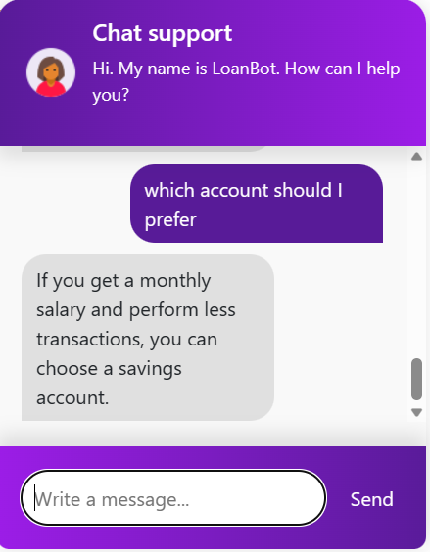

**Figure B.3.3 Chatbot queries-3 Figure B.3.4 Chatbot queries-4**

# 

# Figure B.3.5 Chatbot queries -5

**Figure B.3.6 Chatbot queries -6**

# APPENDIX-C ENCLOSURES

1. **Conference Paper Presented Certificates of all students.**

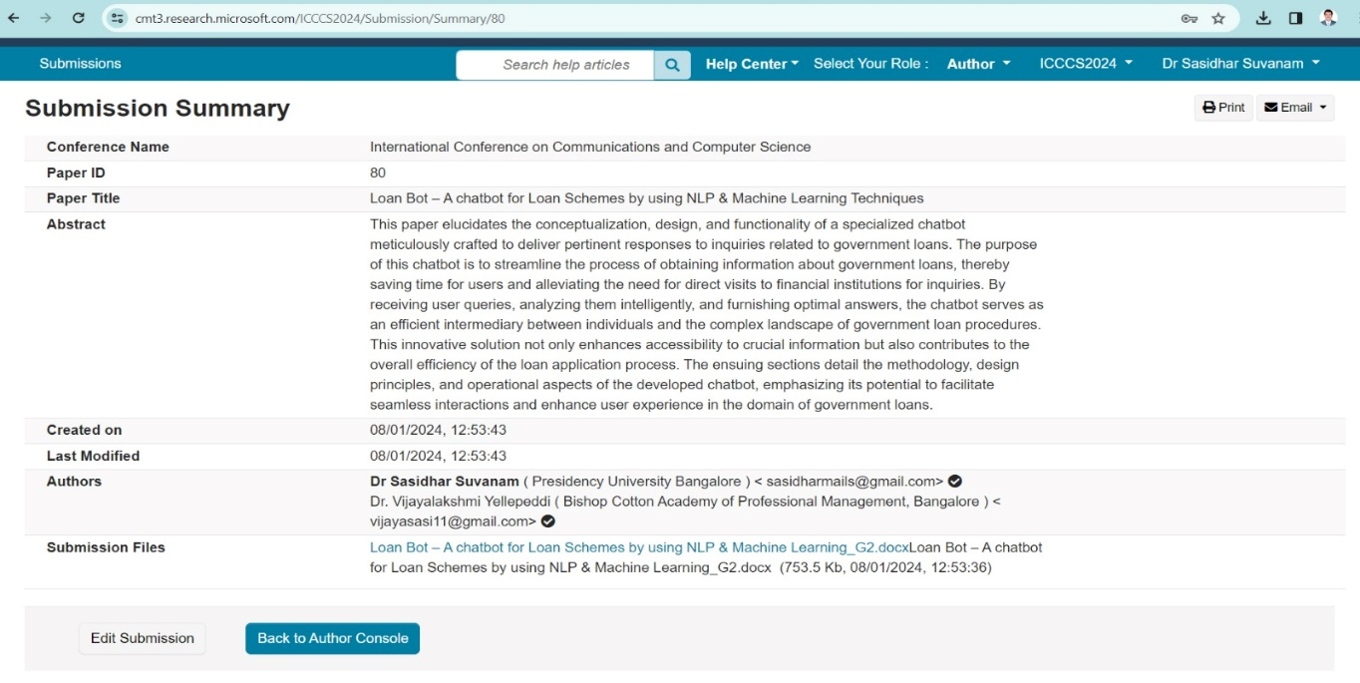

# Include certificate(s) of any Achievement/Award won in any project related event.

# Paper submitted to IEEE Conference (ICCCS 2024) which is organizing by BMS College of Engineering held on May 22-24, 2024.

# <https://incccs.bmsce.in/>

# Paper ID – 80

1. **Similarity Index / Plagiarism Check report clearly showing the Percentage (%). Attached**

Loan Bot – A chatbot for Loan Schemes by using NLP & Machine Learning Techniques

*by* Sasidhar Babu Suvanam

**Submission date:** 08-Jan-2024 12:36PM (UTC+0530)

**Submission ID:** 2267800881

**File name:** hatbot_for_Loan_Schemes_by_using_NLP_Machine_Learning_G2_1.docx (753.9K)

**Word count:** 2352

**Character count:** 14672

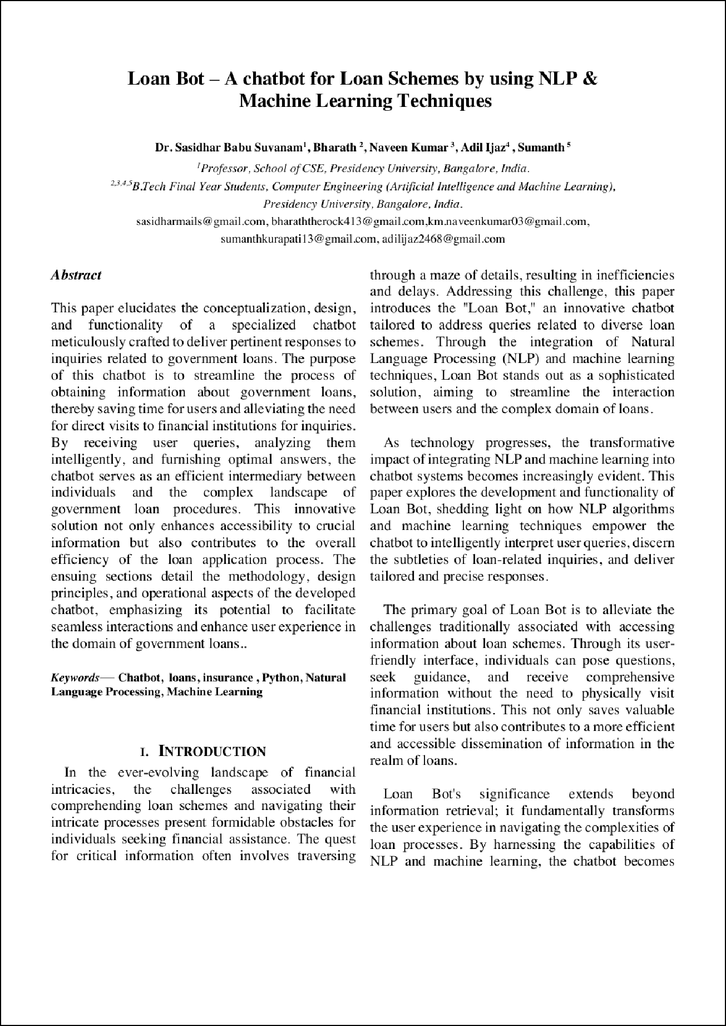

4

1

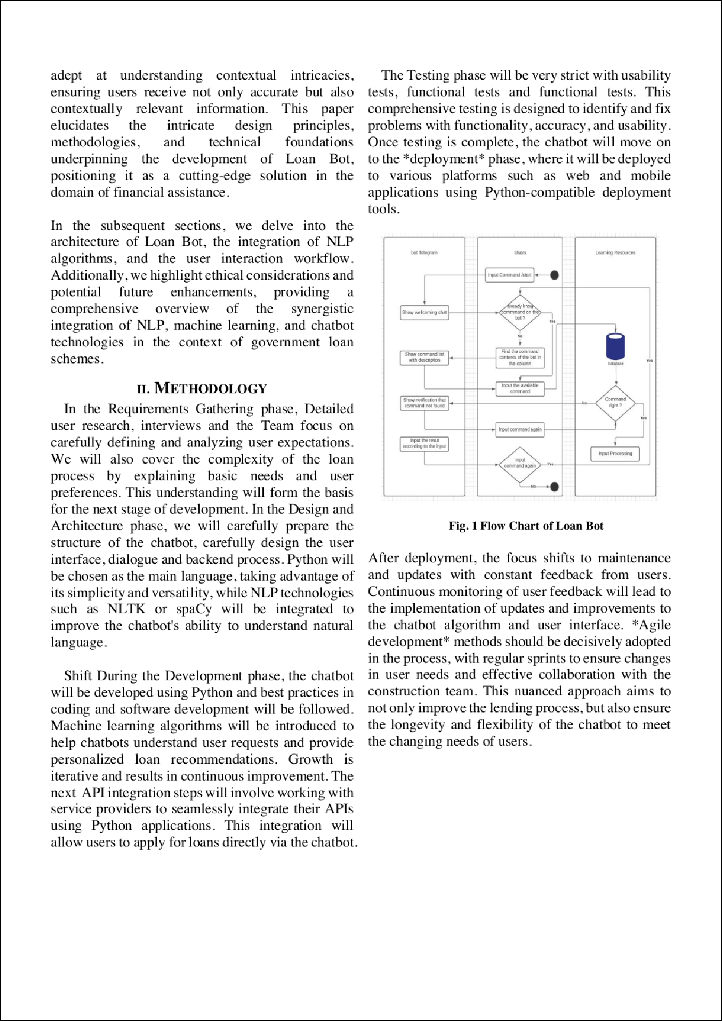

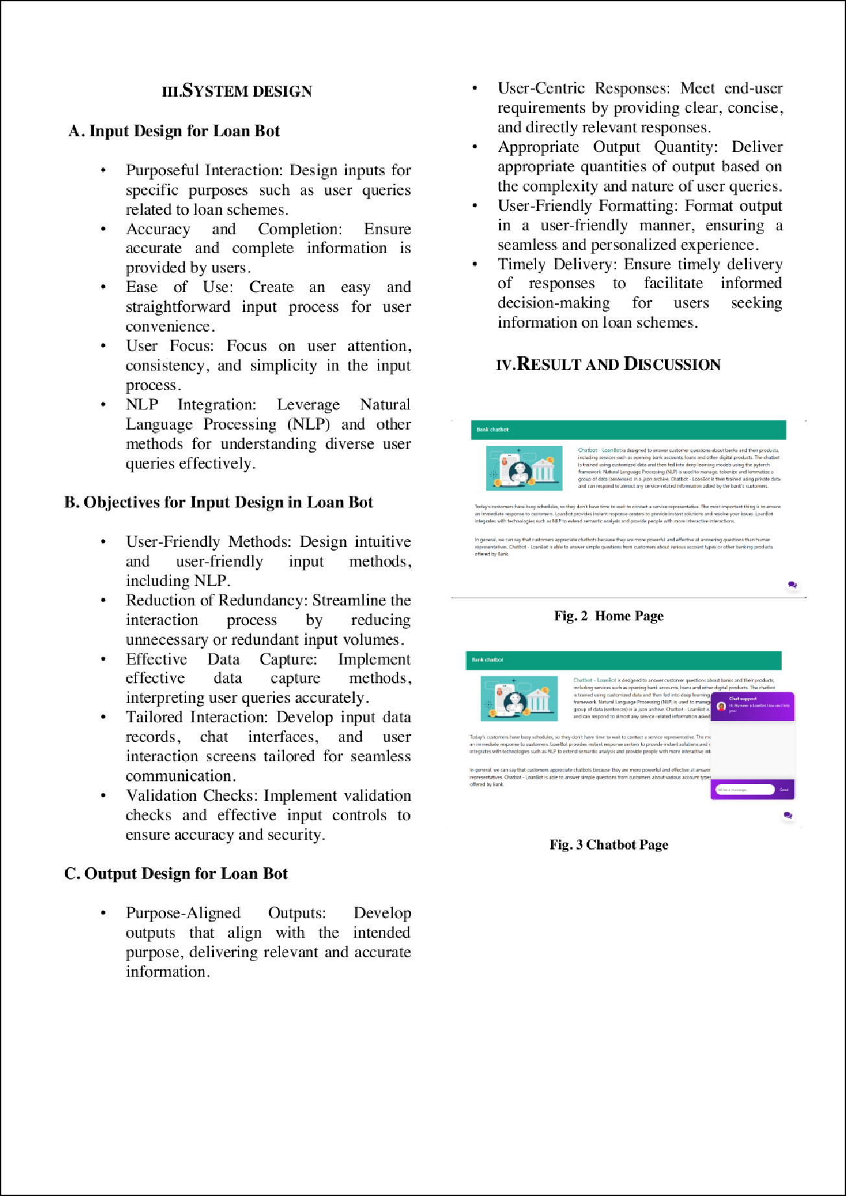

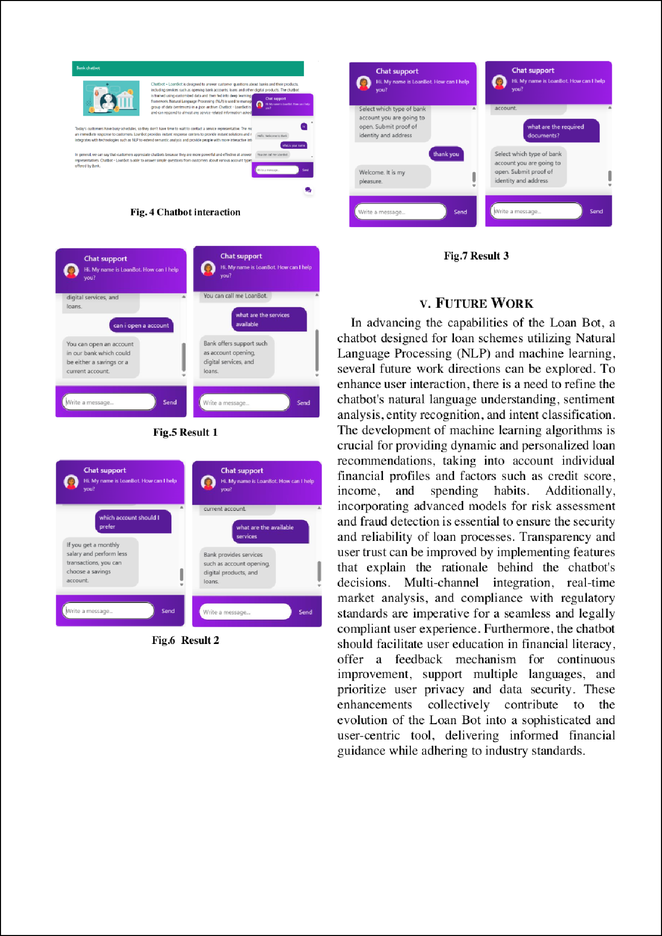

2

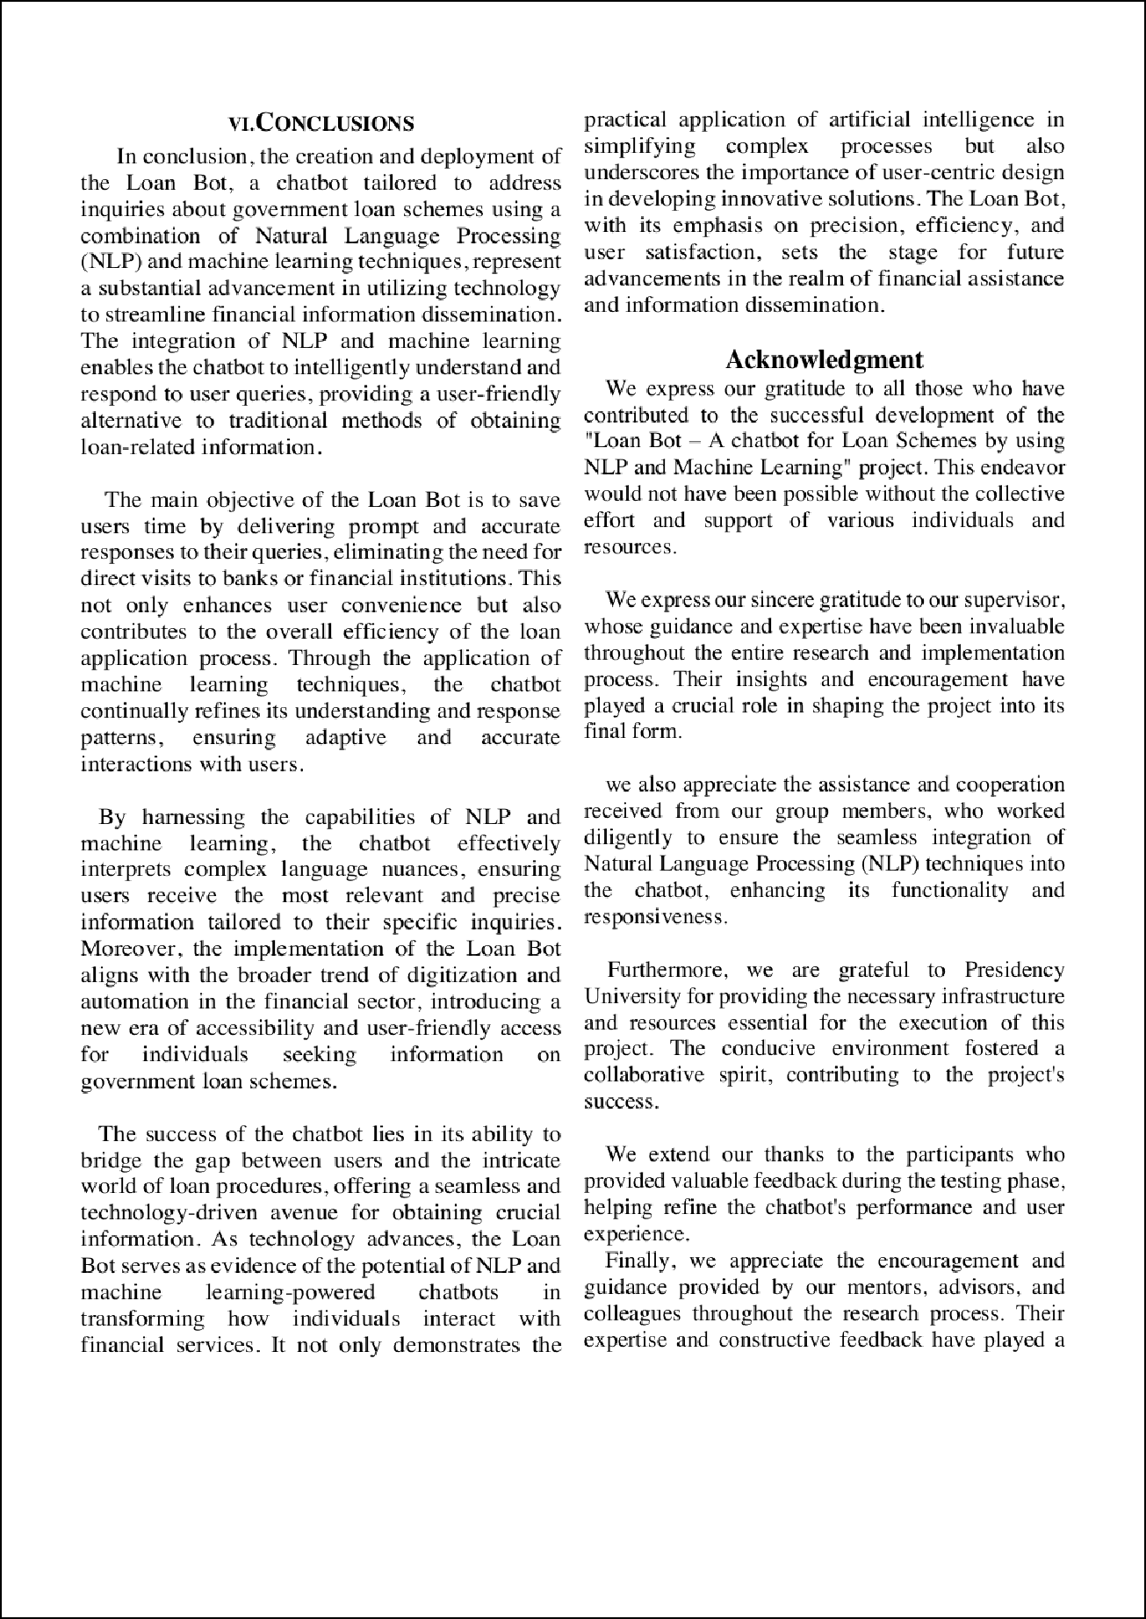

1

3

